|  |
| --- |
| University of Lincoln |
| Level 3 Project |
| Zach Jones (JON11356270) |

“*You Scratch My Back, I’ll Scratch Yours: Supporting collaboration with a virtual economy system*”

# Abstract

# Introduction

[ENSURE ENTIRE REPORT IS IN PAST TENSE]

[Add references to methodologies]

# Background

The importance of collaboration between students in all levels of education has been explored thoroughly, with such research as “Processes and Consequences of Peer Collaboration” (Tudge, J., 2008) finding it to be a greatly beneficial learning technique compared to the more old-fashioned and solitary style of studying. The main benefits of small group work is its ability to enhance relations between students of varying backgrounds (Nieto, S., 1992) and provide skills that are “essential for authentic achievement” (Cohen, E., 1992); furthermore, working collaboratively with others improves students’ ability to create strong co-worker relations, which can be transferred to post-education work scenarios (Cohen, E. and Lotan, R., 2014).

In the workplace, it is becoming increasingly important for employees to solve problems collaboratively due to the organisational and social benefits for both the company and its workers (Tjosvold, D. & Tsao, Y., 1989). Cooperative interdependence leads to stronger working relationships and more effective approaches to complex tasks (Tjosvold, D., 1988), given that they require knowledge that no single person could obtain, therefore mandating collaboration between multiple disciplines, as explored by Zhu, et al (2010). The knowledge transfer between peers of varying expertise has been shown to have a positive impact on the productivity of many types of organisation ([Argote](https://scholar.google.co.uk/citations?user=lgaWJAkAAAAJ&hl=en&oi=sra), L. and [Ingram](https://scholar.google.co.uk/citations?user=j8J8D7YAAAAJ&hl=en&oi=sra), P., 2000; Nembhard, D. and Bentefouet, F., 2015) and therefore, it could be determined that a system encouraging peer collaboration and the transfer of knowledge would be a valuable tool for social and economic development.

It is important to note, that while there are obvious benefits to creating a system that encourages cooperative work, certain group dynamics can hinder communication and knowledge transfer, such as a “*leader-centred*” approach (Toseland, R. and Rivas, R., 1984) which constrains groups and stifles creativity in favour of achieving tasks set by the leader. As an addition to the style of group, a further obstacle to effective collaboration is that when rewards are used inappropriately, with win/lose conditions or when collaborators are encouraged to work individually, competition instead of cooperation is induced, leading to each member feeling reluctant to aid others as it may cause their own goals to become more difficult to attain (Tjosvold, D. & Tsao, Y., 1989).

Given the aforementioned pitfalls that are likely to occur in collaborative tasks and the fact that “*student attitudes to group work, in general, are mixed*” ([Elgort](https://scholar.google.co.uk/citations?user=VW_DU3UAAAAJ&hl=en&oi=sra), I., et al, 2008), the creation of an effective system that encourages peer collaboration would have to overcome the obstacle of apathy in a semi-structured manner, as to allow freedom of expression and facilitate a “*group-centred*” experience (Toseland, R. and Rivas, R., 1984). Student apathy has been found to be “*as common as chalk dust*” (Raffini, J., 1988), and has been cited as one of the “*causes for great concern*” by Boyer, E. and Student Personnel Administrators (1990). In the current generation, apathy is thought to be fuelled by the social disconnection brought about by the increase of technological communication (Luther, N., 2009); therefore, in order to challenge apathy and successfully foster a much-needed collaborative work flow, a system that forces a temporary disconnection and social contact between peers is needed.

A second factor that remains important to the effectiveness of any collaborative process is the group size that is forced upon a cooperative team. Much research suggests that, in order to provide all members with an opportunity to participate and learn, groups need to remain small in membership (De Cremer, D. and Leonardelli, G., 2003). Further research into the area of inter-group collaboration shows that the engagement of group members is directly linked to each individual’s need to belong (Baumeister, R. and Leary, M., 1995) and that as group-size increases, the belongingness of each person is reduced (Komorita, S. and Parks, C., 1994).

To persuade peers to work together using a collaborative system, each user needs an incentive so that they have a reason to cooperate and care about each other’s progression (Slavin, R., 1984). With Deterding, et al (2011) stating that the core idea of any persuasive application is “*…to model the reward and reputation systems of gamified applications with economically inspired approaches such as incentive centered design*”, it is suggested that a possible way to challenge apathy and encourage collaboration could be through the use of incentive mechanisms.

Regarding incentive-centred design, it has been found that applications utilising rewards as a product of positive interaction has increased both participant motivation and most importantly, participation (Hummel, et al, 2005; Small, 2002). Further evidence supporting the use of incentive-centred design is the large amount of research concerning the neurological rewards system (i.e. Milner, P., 1991; Thut, G., et al, 1997; McClure, S., et al, 2004[1]), which was originally observed by Olds and Milner (1954), who found that when certain loci of the brain are stimulated, subjects will attempt the action that caused the stimulation again. Through the use of incentive mechanisms such as monetary rewards (McClure, S., et al, 2004[2]), it is hoped that users of a collaborative system will be encouraged to continuously use it as a platform for supporting their own collaboration.

Along with currency, reputation/karma systems have been shown to improve friendly and reliable user interactions with a system due to their ability to visualise the ‘trustworthiness’ of each member (Jøsang, A., et al, 2007) and furthermore are another key activator of the human rewards system (Izuma, K., et al, 2008). Farmer and Glass (2010) note however, that while reputation systems can be used to provide “*a means for trust between users*” and encourage users to contribute to services, they should be used sparingly and almost never be displayed publically.

Contrasting the merits of incentive-centred design is the human nature of altruism, where an agent provides aid to someone with whom they are not related, for no personal gain (Trivers, R., 1971). Fehr and Fischbacher (2003) state that, while not every person in a group can be fully selfless and altruistic, the existence of a few altruists can positively affect the nature of those around them; therefore in an online community, it may be possible for altruism to become to main motivator for collaboration. The biggest drawback to relying on altruistic agents in a collaborative system is that ‘true altruism’ is very difficult for people to attain, due to the high probability of subconscious motives for aiding another, such as: “*social pressure, guilt, sympathy or simply a desire for a ‘warm glow’*” (Andreoni, J., 1990). Further research concerning group work supports Andreoni’s idea of ‘impure altruism’, where it has been found that while some groups appear to collaborate, each member is driven to complete their own personal goals due to a lack of understanding the value of others within the team (Sonnenwald, D. and Pierce, L., 2000). Through the use of incentive-centred design and ‘gamification’, it would be possible to define rules and rewards for cooperation (Pagulayan, R., et al, 2002) and therefore discourage the selfishness that Sonnenwald and Pierce describe.

Aims and Objectives

Given the findings of the literature review, this project will involve designing and creating an app that encourages collaboration by providing virtual monetary rewards for collaboratively aiding fellow users, with a specific feature of allowing people to post tasks with which they require assistance. To determine the artefact’s effectiveness, user-testing will be conducted with a group of computer science students at the University of Lincoln.

The development of this system, hereby referred to as ‘Backscratcher’, will be split into the following objectives:

Minimum Viable Product

* New users can create a ‘Backscratcher’ profile, which has its own credit balance and linked tasks
* Users will be able to create tasks, which will then be viewable by others in the task forum; the credits offered should then be removed from the current user’s account
* After a task has been accepted by a user and subsequently completed (via a dual-user authentication), the pre-set credit reward should be added to the helper’s account

Further Improvement

* There could be a messaging system on each task, which allows users to find out more details concerning the desired collaboration
* A tipping feature could be added, allowing users to tip others an amount of credits, which would provide an interesting metric concerning altruistic behaviour in collaboration

The decision to only test ‘Backscratcher’ with students from the University’s School of Computer Science was so that use-case testing could be done quicker, given the control groups common subject and location. Furthermore, it is understood that whilst the system has the potential to be used by all students and even the general public, the scope should be limited for the length of this research, as it is most important that the system’s ability to support collaboration be determined before any extra features are added.

* Importance of collaboration (refer to education)
* Collaboration in education/development

1. (<https://books.google.co.uk/books?hl=en&lr=&id=pXDHAAAAQBAJ&oi=fnd&pg=PP1&dq=social+collaboration&ots=ZXUB2TfyEf&sig=CgWoJdv_pWzLZlj7cKSdF1uuqiw#v=onepage&q=collaboration&f=false>) Book - Digital Education: Opportunities for Social Collaboration
2. (<http://www.tandfonline.com/doi/abs/10.1207/s1532690xci1004_1>)

* Collaboration in the workplace and knowledge transfer

1. (<http://onlinelibrary.wiley.com/doi/10.1111/1467-6486.00214/abstract;jsessionid=665EB4E0A7B5ACFA616EC181403936C3.f02t01?userIsAuthenticated=false&deniedAccessCustomisedMessage>=)
2. (<http://www.sciencedirect.com/science/article/pii/S0749597800928838>)
3. General link to knowledge transfer articles

* Gaining an understanding of teamwork

1. (<http://www.emeraldinsight.com/doi/10.1108/TPM-02-2015-0006>)

* Critique group work
* Ways to encourage collaboration and overcome boundaries
* Link to previous

1. (<http://researcharchive.vuw.ac.nz/handle/10063/334>)
2. “The results highlight the fact that student attitudes to group work, in general, are mixed, and that the use of wikis per se is not enough to improve these attitudes.”

* “Bystander apathy”/”Student Apathy” -> Discuss problem and define solution

1. (<http://eric.ed.gov/?id=ED297198>)
2. “A fourth strategy for inviting apathetic students back to the learning process is through the use of cooperative learning activities.”
3. (<http://boyerarchives.messiah.edu/files/Documents4/1000%200001%206749ocr.pdf>)
4. “…a purposeful community, a place where the intellectual life is central, and where faculty and students "work, together" to strengthen teaching and learning on the campus.”

* Maintaining small groups (also mentioned above)
* Importance of social contact in learning

1. (<http://www.nacada.ksu.edu/Resources/Academic-Advising-Today/View-Articles/Advising-in-the-Face-of-Apathy-Collaboration--Connection--and-Communication-in-Higher-Education.aspx>)
2. “student dependence upon technology is actually resulting in disconnection and disengagement from the human, social contact needed to successfully collaborate, connect, and communicate.”

* Incentive-Centred design
* Why?
* Reputation/Karma Systems
* Altruism
* Contrast to Altruism
* Aims and objectives (derived from lit review)

Find in library?

<http://sw.oxfordjournals.org/content/48/3/297.short>

<http://sth.sagepub.com/content/21/1/54.short>

<http://dl.acm.org/citation.cfm?id=332502>

<http://www.sciencedirect.com/science/article/pii/S0360131504000570>

# Methodology

# Project Management

<http://www.businessballs.com/project.htm>

This research project will attempt to determine if the use of a virtual currency can help to foster working relationships between peers and encourage people to collaborate on tasks. It is hoped that the participants will feel encouraged to collaborate with their peers, in the knowledge that they will receive a ‘reward’ (in the form of a virtual currency) for doing so. In order to test participant’s response to this idea, an artefact that provides the reward transaction interface and social networking will be required. Along with the software development required, the project management methodology should be chosen so that it allows for a considerable amount of time to conduct user tests and evaluate the results both qualitatively and quantitatively, so that collaborative interactions between the participants can be monitored. Furthermore, consent forms and semi-structured interviews must be created for the testing sessions.

# Software Development

<http://www.itinfo.am/eng/software-development-methodologies/>

As shown in the initial objectives, the artefact required for this project must facilitate participant communications and handle a virtual economy. Due to the level of analysis that will be undertaken, in order to determine the system’s effectiveness, a flexible development process will allow for certain features to be omitted should the time be required for user testing. Along with an iterative focus, the type of software development methodology used for this project will also need to be a rapid one, as it will allow for quick updates to the system, meaning that the time constraints attached to this project will not cause any dramatic set-backs due to the lack of a working system.

**Dynamic Systems**

A benefit of dynamic systems development is its focus on the frequent delivery of products through an iterative cycle. A limitation to this method, would be its focus on including users in the systems development, given that the participants might have a bad experience with an early prototype and be reluctant to use the artefact during testing, which would negatively impact the validity of the gathered data.

**Spiral**

Like dynamic systems development, the spiral methodology focuses on iterative production; however, it removes the inclusion of participants during the cycle. A consequence of using this method would be that the initial iterations would take longer to complete, as each prototype much be evaluated and its potential risks determined; whilst this could provide a robust system for a lengthy development process, it would only hinder a project of this magnitude, as it may take too long to develop a ‘low-risk’ prototype. Furthermore, given the project’s main aim is to determine if a rewards-based system could encourage collaboration, an in-depth and fully robust system will not be required.

**Scrum**

The scrum methodology would also provide the speed required for a project this short, given the use of ‘short sprints’; however, this structure would not allow for lengthy periods of working, nor does it account for user testing. A further limitation of using this method is its reliance on defining a set of features to work on, which would hinder the reactive addition of new features.

**Rapid Application Development (RAD)**

This methodology encourages the re-use of software and proposes that a prototype does not need to be efficient in order to achieve its purpose, this structure is perfect for the requirements as it allows schedule flexibility and iterative prototyping. Design improvements are delayed until a working system has been created, which will allow for the focus of testing to remain wholly on the system’s effectiveness at encouraging collaboration, rather that its aesthetic features. Finally, the use of a RAD methodology will not constrain the length or type of user testing, enabling it to be conducted whenever it is necessary.

Given its practical relevance to the system requirements, the artefact will be developed using a Rapid Application methodology. In order to ensure each successive prototype improves on its predecessor, each iteration will be comprised of a design, implementation and testing phase. By using these three stages of the software development lifecycle, it is hoped that the artefact will be improved each iteration, until testing can be conducted.

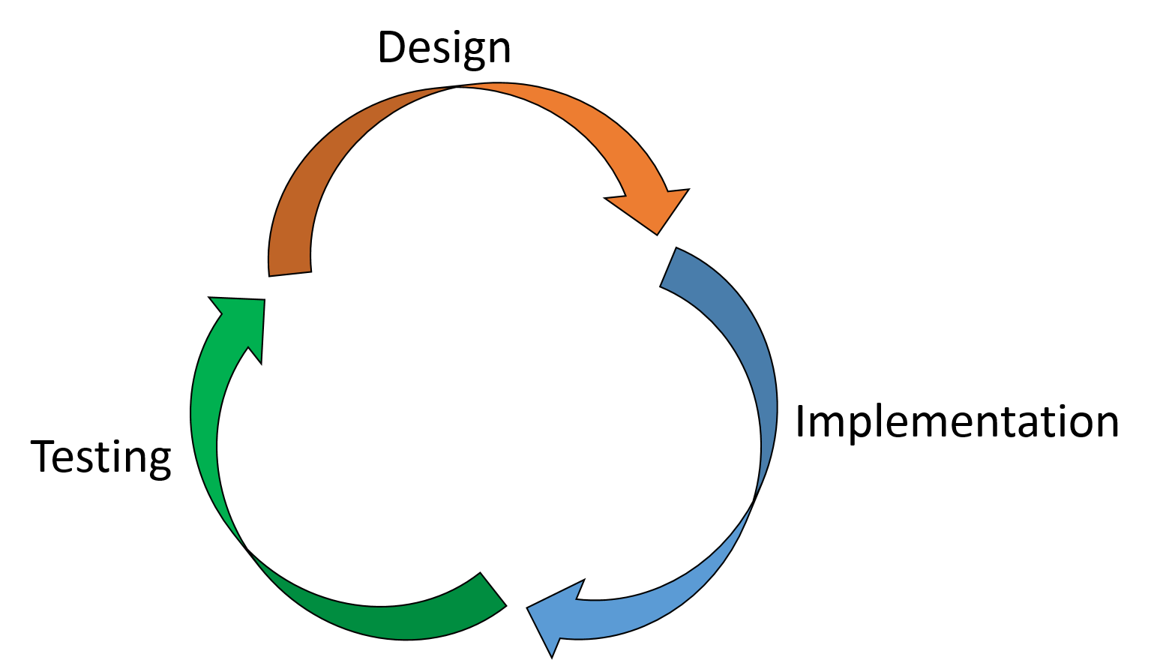

# Toolsets

<https://en.wikipedia.org/wiki/Comparison_of_web_frameworks>

As mentioned, the required system should allow co-located users to interact in the same space, planning social collaboration and organising workflows; because of this, the artefact should be created using a web application framework, so that connectivity between participants can be ensured. As it has been discussed, the desired system should have room to expand and improve, should it be deemed successful, therefore mobile application capabilities would enable growth into other technological sectors for further studies. The code-base must also have the ability to update systems after each new development, in order to provide real-time updating during the testing period. Rapid updates will also provide a smoother messaging experience for users, as they will need to get responses asynchronously, without latency.

**Meteor [Javascript]** (Meteor Development Group, 2012)

* Mobile and web development platform
* Provides actionable metrics, for iterative analysis
* Updates all connected browsers at once
* Provides latency compensation and conflict resolution
* Has many libraries for additional functionality
* Good documentation, allowing for rapid learning

**Laravel [PHP]** (Taylor Otwell, 2011)

* Fast app deployment
* Good documentation
* Easy authentication with existing API’s
* Database seeding will populate database tables for testing purposes
* Reverse routing allows for rapid updating of URIs

**Catalyst [Perl]** (Sebastian Riedel, 2015)

* Provides interfaces to web servers and receiving page requests
* Uses a ‘Don’t Repeat Yourself’ principle
* No code required for the database layer
* Enables the re-use of existing Perl modules for handling common web app concerns
* Has a large selection of plugins

After researching multiple web application frameworks, Meteor seems to be the most expansive tool set, as it allows for easy portability across web and mobile, as well as being centred around the idea of rapid prototyping, which will be required for the desired iterative life cycle. The ability to automatically propagate updates to the system in real-time will allow for a much faster turnover between implementation and testing.

# Research Methods

<http://www.simplypsychology.org/research-methods.html>

<http://www.nfer.ac.uk/schools/developing-young-researchers/how-to-choose-your-research-methods.cfm>

[Experimental HCI]

In order to evaluate the success of the artefact, the collaboration between users will need to be evaluated thoroughly; therefore it is important to review the current methods of research, including testing and evaluation, so that this project can provide insight into how peer collaboration can be encouraged. All styles of data gathering falls under the heading of ‘Qualitative’ or ‘Quantitative’, but which is better? In her book “Quantitative versus qualitative” (1995), Bavelas discusses the two types of data and concludes that both methods have their own merits and that researchers should remain open to both, “*letting your data find their own best fit*”. Given that the benefits and limitations of the most-used research methods have been discussed in full by other researchers in the past (e.g. McLeod, S., 2007; National Foundation for Educational Research, 2015), their relevance to this project will be discussed, rather than each method’s generic pros and cons.

Experiments

**1) Laboratory**

Since this project intends to understand how a real-world application can be used to encourage natural collaboration between peers, it would be highly inappropriate to constrain participants to the controlled environment that a lab experiment demands, as the results gained would not mirror the real-world interactions between those who take part. Furthermore, the use of this type of study would force the tests to be short and not provide any insight into the potential long-term use of the system.

**2) Natural**

As the confined nature of a laboratory experiment would be too sterile and make the research ecologically invalid it might be important to have zero control, allowing participants to move freely and remain unaware of the tests being conducted. The major inconvenience of using this research method is that it would be very detrimental to the time constraints of this project, as can be seen in Hodges’ and Tizard’s study on ex-institutional adolescents (1989), which lasted multiple years. As well as the obvious time considerations, a natural experiment could not be altered by the researcher to negate extraneous variables, meaning that bias could enter the study and possibly nullify the results.

**3) Field**

Given the two extremes above, it can be seen that a middle ground is required for this project, therefore a field experiment will be conducted. The decision to use this methodology is due to its ability to reflect the real-world, with such factors that would affect collaboration being present, meaning that the effectiveness of the system at deterring these negative factors can be evaluated. Along with enabling extraneous variables, field experiments would allow the researcher to define certain constraints to the participants’ interaction, allowing bias to be controlled when required.

Data-Gathering

**1) Structured Interview**

Due to the time constraints of the project, structured interviews would be beneficial to conduct with participants post-experiment, in order to obtain their responses to artefact, due to their structural reliability and a lack of deviation from the questions; however, the inflexibility of this data-gathering method does not allow for open questions or detailed answers from participants, which would be detrimental to this study as it would not generate any qualitative results, making it impossible to discover why the users interacted with the system in the way that they did.

**2) Semi-Structured Interview**

The lack of depth provided by structured interviews can be ratified through the use of a semi-structured approach, given that it allows for deviation from the pre-written questions and in-depth probing of the users’ experiences. The major limitation of this interviewing method is that it may take a long time to interview each participant individually, since the length of the interviews cannot be predetermined.

**3) Group Interview/Focus Group**

In order to ensure all participants are interviewed in a timely fashion, a focus group method should be implemented along with the semi-structured questions, allowing multiple people to be interviewed in a single session. Should this method be used, it is important that the interviewer ensures that the conversations do not deviate too far from the original structure, as that could make the process lengthy and the data unreliable.

**4) Questionnaire**

Given that some participants’ answers could be affected by the presence of others in the focus group, a small amount of semi-structured interviews could also be conducted, ensuring that bias is removed from the data; however, even a small collection of singular interviews could take a lengthy amount of time to conduct. Therefore, in order to obtain anonymous and personal feedback from each participant, questionnaires should be used. Through the use of both closed and open questions, the qualitative data of semi-structured interviews can be attained, without the time requirements for the interviewer. Furthermore, the use of this method allows each participant a level of anonymity, meaning that their answers may be more genuine than those given during a face-to-face interview.

# Design, Development and Evaluation

**1.** Requirements collection and analysis (Small – link to lit review), design (Small – Mention lack of need for good visuals?)

The design specifications for the artefact was generated from the analysis of relevant literature conducted earlier in this report. It was found that the desired system would need to use an incentive mechanism to test whether peers feel encouraged to collaborate if their rewards system is stimulated. Given the research conducted by Thut, et al (1997) in the paper “Activation of the human brain by monetary reward”, it was decided that a form of financial incentive would be the best way to stimulate users to aid their co-workers; however, given the ethical pitfalls that could occur when transferring valuable currencies online (Leeson, P. and Coyne, C., 2005; Bhattacharyya, S., et al, 2011; Anderson, R., et al, 2013), it was decided that a bespoke, virtual currency would be best.

During the literature review, it was found that smaller group sizes are more effective at encouraging collaboration that is beneficial to all participants (De Cremer, D. and Leonardelli, G., 2003), therefore ‘Backscratcher’ was designed so that only one user would be allowed to accept a task, at which point it would be removed from the view of other participants. Furthermore, the analysis of Luther’s work (2009) deduced that users should be highly encouraged to collaborate away from technology, in order to enable social collaboration to take place. It should be noted however, that the artefact was not designed to force physical collaboration, because anonymity provides users a level of freedom in determining when and how their personal details are revealed (Chester, A. and Gwynne, G., 2006), creating an environment where the participants can feel secure and control the flow of collaboration.

3. Building or coding (Medium-large)

In order to ensure that the research conducted for this project is ethical, participants have been kept anonymous and were provided with a consent form (below) which was designed to be clear and concise (Loverde, M., et al, 1989).

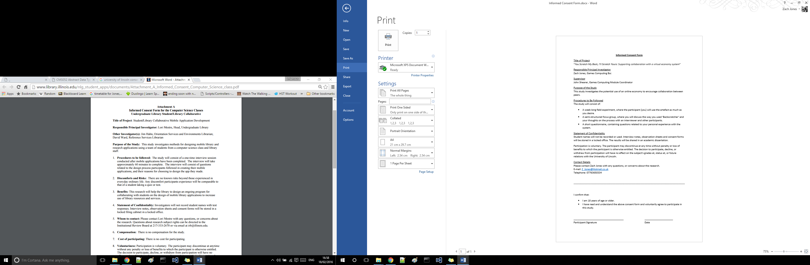

**5.** Study design (short summary of research methods section) – including hypotheses. (Small-Med)

As discussed in the Research Methods section, all participants took part in a week-long field experiment, where they were told to use ‘Backscratcher’ as little, or as much as they desired, it was determined that by conducting the research gathering in this manner, users would be afforded the freedom of a non-testing environment and could provide an insight into the possible real-world usage of a currency-based collaborative platform. Following their experiment, participants then took part in focus groups and answered questionnaires, so that their use of the system could be analysed.

In order to ascertain the participants detailed opinions on the system and what changes might be needed, qualitative focus groups were conducted with participants.

**Focus Group**

1. What did you think about the use of a virtual currency?
2. Have you used any form of collaborative platform before?
3. What made you want to contribute (or not) to the service? Why?
4. Would you use the system again? Why?
5. What changes would you make to the system?
6. Did you use the ‘tip’ system? Why?

Given the focus group’s qualitative approach, the questionnaire was designed to provide a form of quantitative response to the artefact.

**Questionnaire**

1. Did you like the system?
2. On a scale of 1 to 10 (1 being not at all, 10 being everyday), how much did you use ‘Backscratcher’?
3. Did knowing that you would receive compensation encourage you to help others?
4. Do you think that you collaborated more whilst using ‘Backscratcher’ than you normally would?
5. How many people did you work with?
6. How would rate the usability of ‘Backscratcher’? (1 being unusable, 10 being perfect)
7. Overall, how would you rate ‘Backscratcher’? (1 being unusable, 10 being perfect)

6. Testing (Med-Large – **mention the ongoing testing by myself**, then user-testing {7})

7. A detailed description of the procedure that each study participant experienced. Include every detail that would be needed in order to replicate your work.

8. Results of experiment – present in the format of a scientific report. (As long as it needs to be)

9. Analysis of results. Consider the results of your work with respect to both your own specific hypotheses and wider context identified in your literature review. (Med-Large)

(Smith, C. P. (Ed.). (1992). Motivation and personality: Handbook of thematic content analysis. Cambridge University Press. 🡨 discusses how to analyse open questions)

[2400 words approx.]

# Project Conclusion

# Reflective Analysis

# List of References

Meteor Development Group (2012) *Meteor.js.* [software] version 1.2. Available from <https://www.meteor.com/> [Accessed 9th November 2015].

Sebastian Riedel (2015) *Catalyst.* [software] version 5.90093. Available from <http://www.catalystframework.org/> [Accessed 9th November 2015].

Taylor Otwell (2011) *Laravel.* [software] version 5.1.19. Available from <http://laravel.com/> [Accessed 9th November 2015].

Chester, A. and Gwynne, G. (1998) Online teaching: Encouraging collaboration through anonymity. *Journal of Computer‐Mediated Communication,*4(2) 0-0.]